Unit Testing
Sign up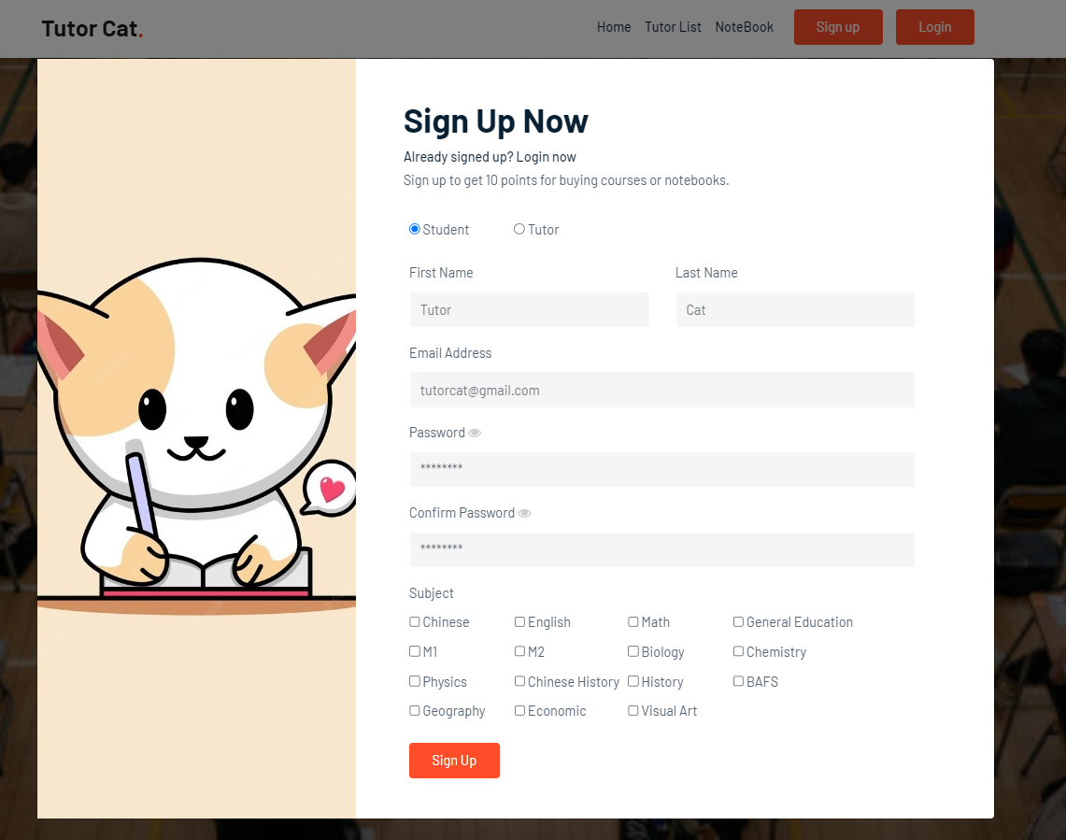
Check role select radio button.
Check system behaviour when a first name is entered.
Check system behaviour when a last name is entered.
Check system behaviour when a valid email is entered.
Check system behaviour when a invalid email is entered.
Check show/hide password button.
Check show/hide confirm password button.
Check system behaviour when a invalid confirm password is entered.
Check subject checkbox.
Check sign up button.
Test Case ID: | TC-001
Test Suite Name: | Test sign up page.
Description: | Test the account sign up for the user.

Steps | Test Data | Expected Result | Actual Result | Passs/ Fail | Remarks
1 | First name:  Tutor | Show text “Tutor” | Show text “Tutor” | Pass
2 | Last name:  Cat | Show text “Cat” | Show text “Cat | Pass
3 | Email:  test@gmail.com | Sign up successful | Sign up successful | Pass | Valid email
4 | Email:  test.gmail.com | Display error message: Incorrect email | Display error message: Incorrect email | Pass | Invalid email
5 | Show password | Show password | Show password | Pass
6 | Hide password | Hide password | Hide password | Pass
7 | Show confirm password | Show confirm password | Show confirm password | Pass
8 | Hide confirm password | Hide confirm password | Hide confirm password | Pass
9 | Confirm password:  Match password | Sign up successful | Sign up successful | Pass | Password match
10 | Confirm password:  Password not match | Display error message: Password not match | Sign up successful | Pass | Password not match
11 | Select subject | Check checkbox |  | Pass
12 | Sign up | Sign up account |  | Pass

Login
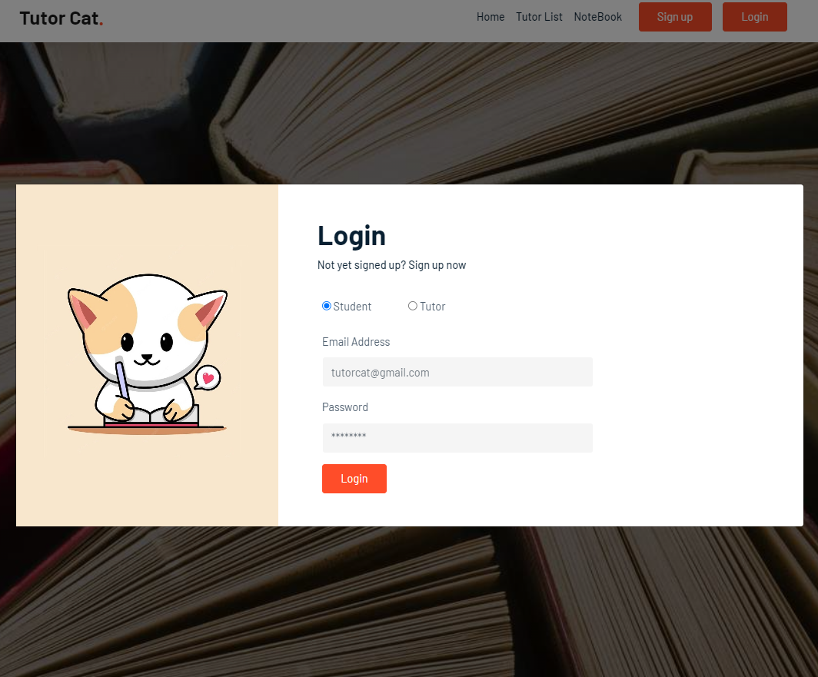
Check role select radio button.
Check system behaviour when a valid email is entered.
Check system behaviour when a invalid email is entered.
Check system behaviour when a valid password is entered.
Check system behaviour when a invalid password is entered.
Check login button.
Test Case ID: | TC-002
Test Suite Name: | Test login page.
Description: | Test login user account.

Steps | Test Data | Expected Result | Actual Result | Passs/ Fail | Remarks
1 | Email:  tutorcat@gmail.com | Login successful | Login successful | Pass | Valid email
2 | Email:  test@gmail.com | Display error message: Login failed | Display error message: Login failed | Pass | Invalid email
3 | Password:  12345678 | Login successful | Login successful | Pass | Valid password
4 | Password:  wrong | Display error message: Login failed | Display error message: Login failed | Pass | Invalid password
5 | Login | Login account |  | Pass

Chat room
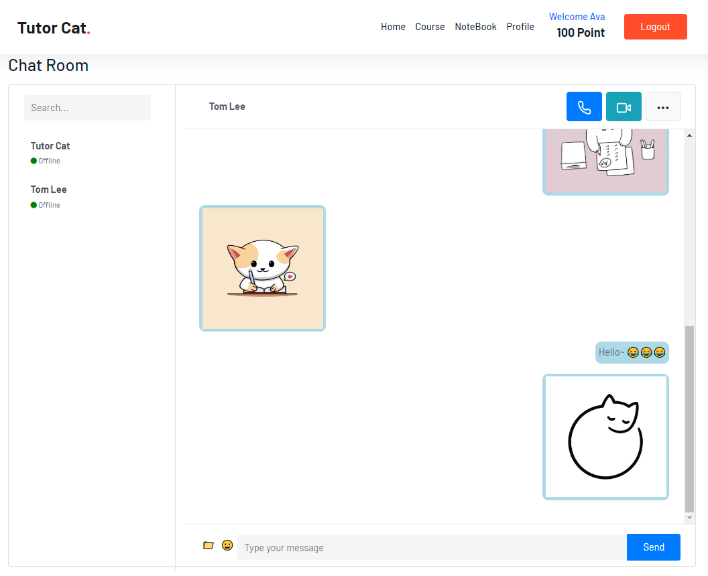
Check user list button.
Check file button.
Check select file button.
Check send file button.
Check Emoji button.
Check system behaviour when text is entered.
Check send button.
Test Case ID: | TC-003
Test Suite Name: | Test chat room page.
Description: | Test chat room to send text, Emoji or file.

Steps | Test Data | Expected Result | Actual Result | Passs/ Fail | Remarks
1 | User list | Show user’s chat | Show user’s chat | Pass
2 | Choose file to upload | Pop up a file select to upload | Pop up a file select to upload | Pass
3 | Send file | Send file successful and show in chat | Send file successful and show in chat | Pass
4 | Open Emoji keyboard | Show a list of Emoji to send | Show a list of Emoji to send | Pass
5 | Send Emoji | Chat box will show the emoji | Chat box will show the emoji | Pass
6 | Send text:  “123” | Chat box will show the text”123” | Chat box will show the text”123” | Pass
7 | Send message | Send message successful | Send message successful | Pass

Payment
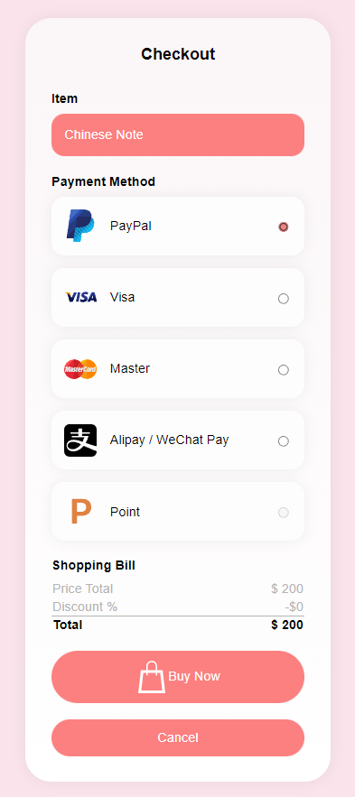
Check payment method radio button.
Check point button.
Check buy now button.
Check cancel button.
Test Case ID: | TC-004
Test Suite Name: | Test payment page.
Description: | Test different payment method.

Steps | Test Data | Expected Result | Actual Result | Passs/ Fail | Remarks
1 | PayPal | Pay with PayPal | Pay with PayPal | Pass
2 | Visa | Pay with Visa | Pay with Visa | Pass
3 | Master | Pay with Master | Pay with Master | Pass
4 | Alipay/WeChat Pay | Pay with Alipay/WeChat Pay | Pay with Alipay/WeChat Pay | Pass
5 | Sufficient point | Pay with Point | Pay with Point | Pass
6 | Insufficient point | Display error alert:  “Insufficient point!!” | Display error alert:  “Insufficient point!!” | Pass
7 | Buy now | Redirect to different payment page | Redirect to different payment page | Pass
8 | Cancel | Back to previous page | Back to previous page | Pass

